**Sikuli X r930 installation**

**Version 1.0**

**Version History**

|  |  |  |  |
| --- | --- | --- | --- |
| **Version** | **Date** | **Handled by** | **Comments** |
| V1.0 | 16-May-2019 | ZL Chen | First version release. |
|  |  |  |  |

Precondition Setting:

Please make sure the JAVA 1.6 has been installed in the system.

Please follow the installation steps as below:

Step 1:

Please find the “Sikuli-X-1.0rc3 (r905)-win32.exe” under the installer folder, then double click this one.

Location: .\automation\installer

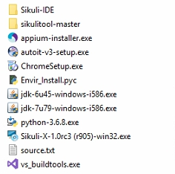

Step 2:

Please click the “Next >” button.

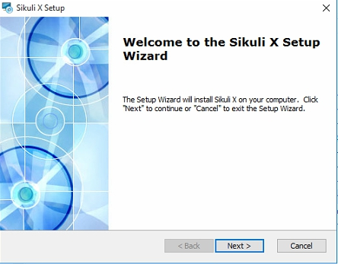

Please click the “Next >” button. 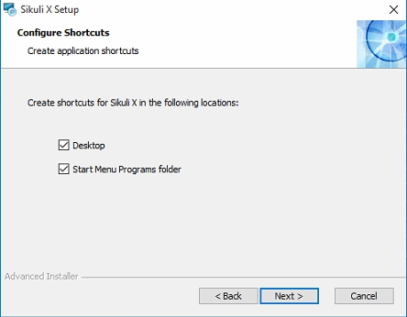

Step 3:

**Remember!!!**

Please make sure the installation path is “**C:\Sikuli-IDE\**”, if is NOT, please modify the path to “**C:\Sikuli-IDE\**”

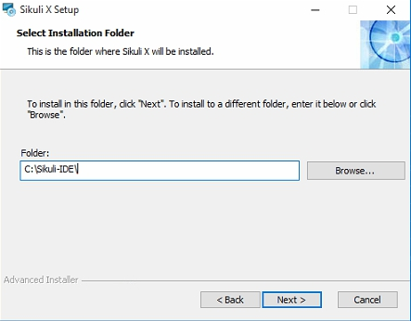

Please direct click the “Install” button.

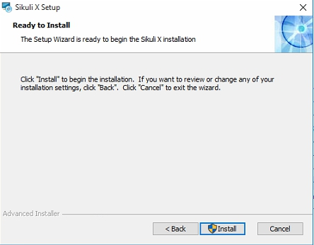

The installation of sikuli X is completed, please click “Finish” button.

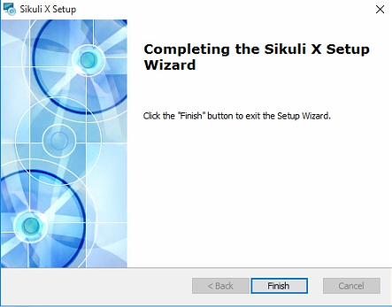

Step 4:

Please copy the “Sikuli-IDE” folder under the .\automation\installer\, then direct replace to “Sikuli-IDE” under the C:\Sikuli-IDE. The action is updating the Sikuli related data.

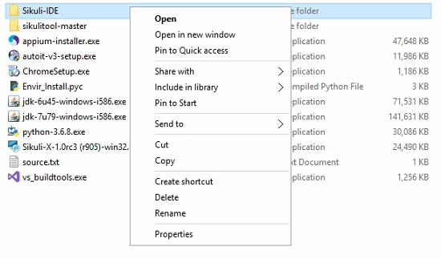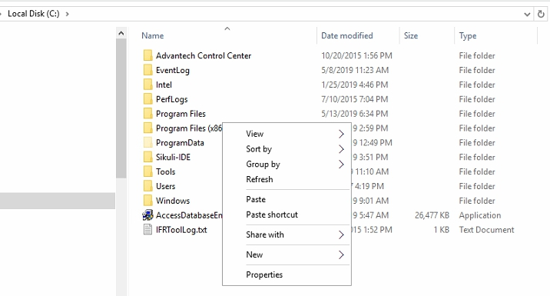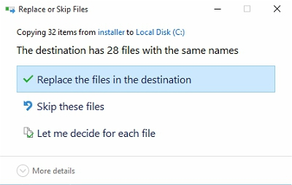

Step 5:

Open the “Sikuli IDE” on the desktop, then click the “Take screenshot” icon.

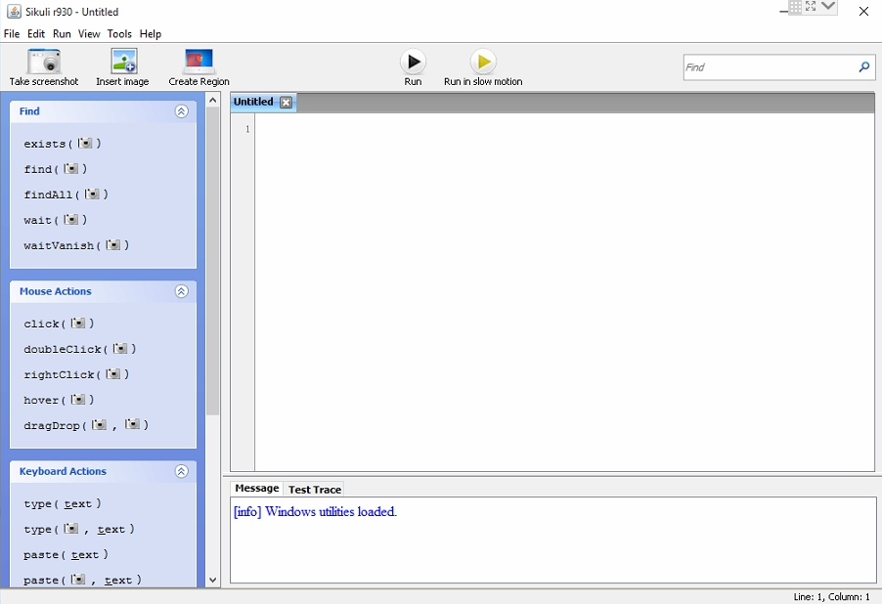

If the desktop window changed to gray, that mains the software can be worked.

